ME 433 HW 1

1. Circuit

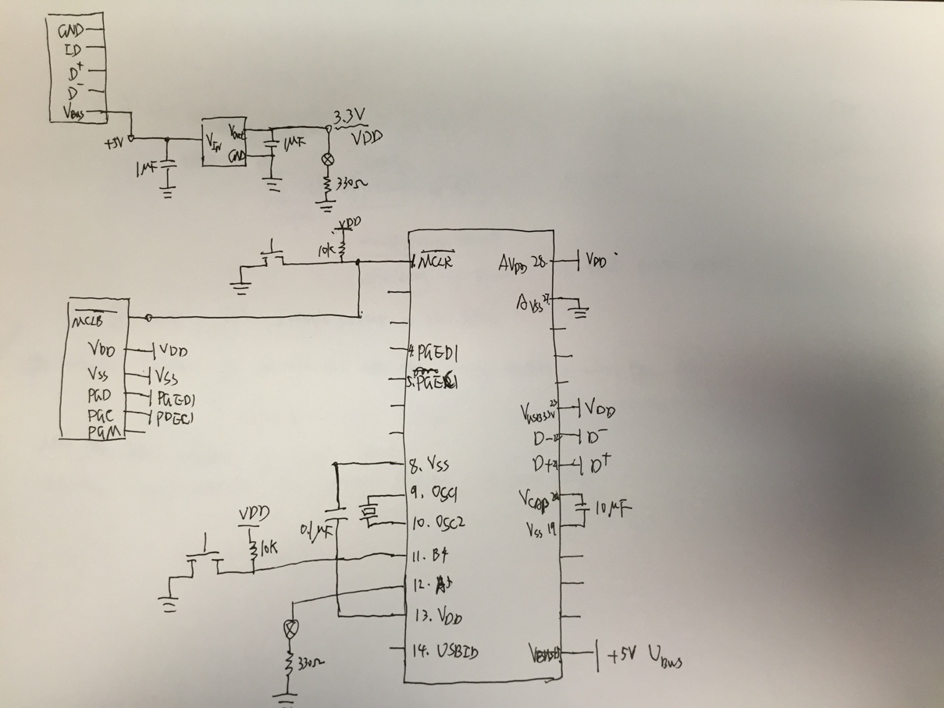

1. A screenshot of the oscillation

When I add output 1uF capacitor, the oscillations go away.

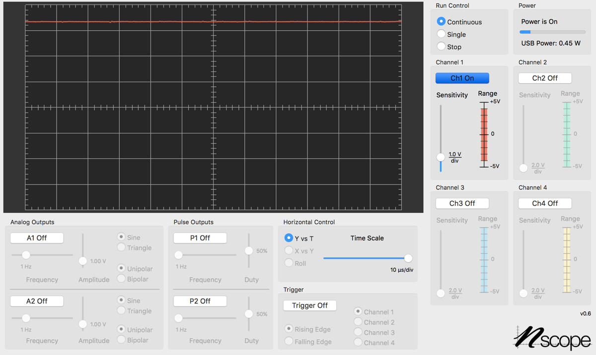

1. A photo of my breadboard

